Escape Rooms Cheat-Sheet

(PU) means that an item can be picked up

# Library Level, Childhood Room

## Things available from the start

* Black Baby Bottle (PU)
* Rattle toy with Red Key (PU)
* Baseball bat (PU) (This is this level’s weapon)
* Xylophone with white keys

## How to solve the puzzle

After picking up the Red Key from the rattle toy, head to the Trophy Case with the red lock and open it. Pick up the Sports Water Bottle inside.

The Xylophone has 8 white keys of receding size. The 8 trophies of receding size have white or red ribbons on them. Walk up to the Xylophone and touch the corresponding keys to turn them red. When done correctly you hear a clicking sound, and a book pops out of a shelf. This book contains Baby Formula (PU).

Combine the Black Baby Bottle, Sports Water Bottle and the Baby Formula. This reveals that the Black Baby Bottle had “paint gaps”; with the contrast of the white milk on the black bottle these gaps are now visible. The word “~~HELP~~” is now seeable in white on the bottle.

Type “~~HELP~~” into the door input to escape.

**Help as a password is being changed right now, because it is confusing for play-testers. Currently testing MILK instead.**

# Library Level, Letter Room

## Things available from the start

Taylor’s letter on top of the Desk with “PS: I LOVE YOU, TAYLOR” written in Tic-Tac code (PU)

## How to solve the puzzle

Notice Painting is crooked because of a dust mark on the wall. When you fix said Painting a Magazine will fall from behind it.

This magazine will enumerate 10 countries:

“1 – Germany; 2 – England; 3 – Canada; 4 – China; 5 – Australia; 6 – India; 7 – the US; 8 – Spain; 9 – Japan; 10 – Russia”

Look at the Globe/Map and write down the colored patterns of the previously mentioned countries, from doing this you should get:

“1 – Blue horizontal stripes; 2 – Green hearts; 3 – ~~Brown~~ **Light Blue/Cyan**; 4 – Purple stars; 5 – Yellow dots; 6 – Brown; 7 – Pink diagonal stripes; 8 – Orange squares, 9 – White triangles; 10 – Red zig zag”

This is the order in which you should put the color patterned books on the bookshelf first blue, red last.

By looking at the way the books are now arranged they make a code “17/07/2019” (this is because the brown books don’t have a number on their back)

Put this code into the locked cabinet of the desk. This will open it and give you a Tic-Tac code translation sheet (PU).

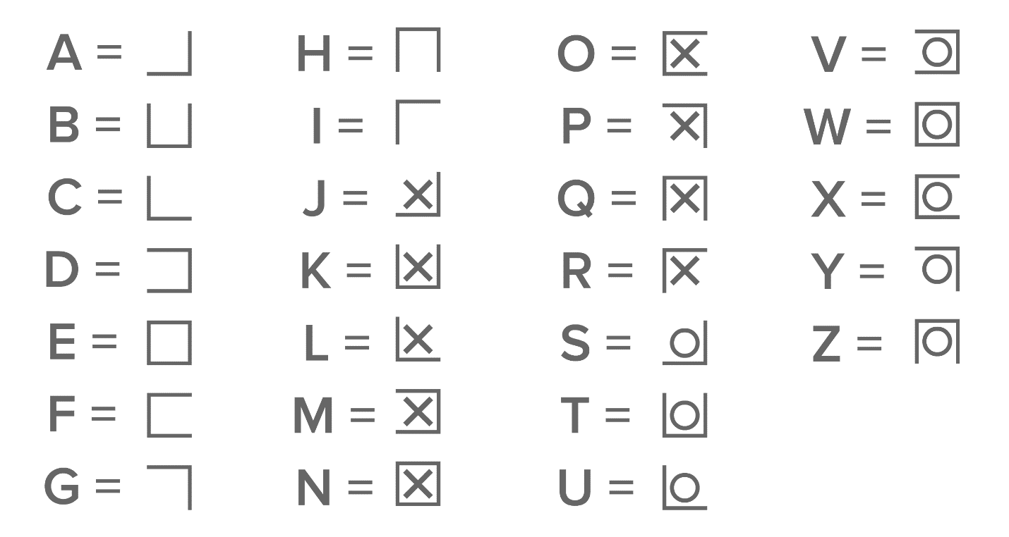

Use this code to Translate Taylor’s letter and then input the message in the box’s code field.

**Currently changing password from “ILOVEYOU” to “TAYLOR” because it was too predictable**

Opening the box gives you a Polaroid of Diego (the outer protagonist) and a kid in a nursery gown with “thank you” written on it.

With this the Room is solved! Present the photo to Anger to start the knowledge test.

**Important remark: Taylor’s name is not supposed to be revealed anywhere other than in the letter.**

# Greenhouse Level

A clear vase for flowers (it doesn’t have flowers inside of it) is fixed to the environment (can’t be picked up). Inside of it there is a Gashapon-looking capsule with a key inside. Since the opening of the vase is too small for the character’s hands, the player has to pick up a bottle of lemonade from a little picnic area and pour its contents into the vase.

The capsule floats due to the lemonade, so now it can be grabbed and opened to obtain a key.

This key is to be used on a heart shaped lock like the ones you see in bridges of tourist locations. This lock is on the picnic basket (located at the picnic area). Inside the basket there is a cellphone and a door handle.

This door handle is to be used on a toolshed. The door handle should have a (hexagonal) hole, and the door should have a little metal piece (that’s hexagon shaped) sticking out.

Inside the toolshed there is a radio. To proceed you have to input an AM frequency. The frequency needed is the same as the time on the big clock somewhere outside in the level (e.g. If it’s 9AM you input 9 Am as the frequency)

If the input is correct, you’ll hear 5 sounds (we need 3-5 different ones) These sounds are scattered on the level, near labeled objects (e.g. The waterfall produces one of these sounds and has a sign with a little icon next to it). You have to input these icons in order into a toolbox inside the shed.

Inside the toolbox there is a lever.

Put lever into electric box near Waterfall and pull to stop the waterfall, revealing a cave.

Inside the cave there is a Tv playing “Forget Me Not”. This has a games console attached to it, interacting with it will give you the game cartridge. Present this to Fear to start the knowledge test.

### Item List for Greenhouse

The greenhouse is *one main room* with a little *toolshed* (toolshed door has a hexagonally shaped metal piece where the handle should go) either inside or as a separate small room, behind the waterfall is a *cave*!

- Vase Statue (the vase is see-through), that is too heavy and big to move / pick up (the vase cannot be picked up). The vase opening can’t be much bigger than a hand, a hand is not supposed to fit through

-Gashapon-looking capsule that fits into the hole of the vase

- Key that fits into Capsule

- Picnic blanket

- Picnic basket

- Lemonade (Glass Jar)

-Love lock like the ones from tourist bridges or we can modify the heart lock to have a little shackle

- Cellphone – Screen has to be separate from rest of cellphone

-Door handle with hexagonal hole

-(Kitchen) Knife

- Radio **(the kind that can play CD’s)**

- Clock (showing a dial with AM & PM, this dial has to be legible to the player)

- 3 - 5 sounds, scattered across level, walking on grass, waterfall noise, +1 (artists can choose these freely as long as there is an according icon to it)

>> Little sign w icons for each sound

- Tool box w icons as the padlock (reuse lock from Level 1)

- Lever (stick)

- Electrical Box for the lever to go into (into the side probably), this turns the waterfall off

Cave with:

Game console w cartridge slit + cartridge (separate objects!)

Tv ((Forget Me Not Playing)), TV Screen : only ONE plain, not a cube!

# The Void

Available from the start:Syringe (with some sleeping liquid inside), this syringe can be placed stuck unto the tree

You enter the room, there is a lone tree standing in this room, the door disappears behind you.

This tree has a dial where you can type in a 5 letter word. The tree branches are shaped in a way that if you look at them from a certain angle of the room you see them form a heart. The player is tasked with realizing this and typing in the word: “HEART”. (This should be relatively easy because this is the only thing in this otherwise empty room, if not we can place broken xylophone pieces on the floor on the spot where you need to stand to see this)

After entering this code in the tree disappears making the 2 objects for our next puzzle appear. The toolshed door where 7 (bunny) doorknobs are placed. And a (frozenly) falling bookshelf where 7 books are floating in the air falling also. The books have a colored tip and are placed in the same pattern as the doorknobs, the only difference is that their tips will be pointing at different directions. Rotating the doorknobs to said locations opens the door.

Opening the door will let you access the toolshed, and will also give gravity to the bookshelf and its books. All but one book fall out of the level. Inside the toolshed there is a CD Player and inside the book there is a CD. Putting the CD inside the CD player lets you hear a past conversation between Diego and Taylor (expressed exclusively through dialog boxes, no voices are heard).

In this recording Diego leaves home and therefore Taylor to have fun out. Yet Taylor doesn’t take this well arguing Diego is hurting them by doing them, the player hears Taylor say that they must make sure this doesn’t happen again.

We then see what they meant when they said this. In the middle of the room are 3 recipients (jugs?) of different sizes on a table. The jugs carry 8, 5, and 3 Liters respectively, and the player is instructed to measure 4 liters to dilute the sleeping agent from the syringe, as it is otherwise lethal. This puzzle in specific mirrors Taylor’s actions.

If you consider the jugs will be placed in the order 8L, 5L, and 3L, with only the 8L jug being full of wine the solution goes as follows:

8,0,0

3,5,0

3,2,3

6,2,0

6,0,2

1,5,2

1,4,3

After mixing the sleeping agent into the 4 Liters of wine Anxiety drinks or is forced to drink the sedated wine.

After this a small kind of cutscene appears where Diego realizes he’s been drugged and needs to escape. When Diego looks at his tired face in a mirror, the cutscene stops (this is out of the players control). The player then should notice that Anxiety is now holding a mirror. This is the Item you need to present to Sadness to progress to the last knowledge test and finish the game.

### Item list for the Void:

-Syringe (the kind for vaccines) (we want to animate the plunger, so it might have to be separated)

-CD

-(hand?) Mirror (can also be a broken mirror shard if preferred)